System Requirements Specification

CSE 361 - SPRING 2014

Pachisi

Jacob Bohac

Aaron Wollman

Joshua Grossman

1. **Introduction**

* 1. **Purpose**

The purpose of this requirements document is to describe our Pachisi software system. The intended audience for this document include the client, project managers, software engineers and system architects. This document is meant to give an overview of the system as a whole as well as describe specific functionality of the system.

* 1. **Scope**

Our system provides a version of the game Pachisi for Android devices. The system is intended to provide users with a board game experience through an easy to use graphical user interface.

The system will allow 1, 2, 3, or 4 player matches. In a future implementation, the system may allow a custom ruleset. These custom rulesets will allow the player to play variants of Pachisi, such as traditional.

* 1. **Definitions, acronyms, and abbreviations**

**AI -** Artificial Intelligence, part of the program that allows players to be controlled by the computer

**Bump -** Occurs when a piece is landed on by another player’s piece. This results in the piece being sent back to it’s starting position.

**Card -** Each turn, a player will take one of these as to determine how their turn will be enacted. There are three types: blue, red, and green. For more information, see Section 5.1.

**Current Player**  - The player who currently is able to pick a card and/or make a move that turn.

**Home -** Last space on the board, each player’s objective is to move their pieces from Start to home

**Start -** Starting position for all of the player’s pieces

**Move -** Interacting with the piece as to place onto the board, or to place a piece in another position on the board.

**GUI -** Graphical User Interface - Visual depiction of the system through which the player interacts with the game

**Grace -** Allows the user to move one of their pieces from Start into the field of play

**Piece -** In-game representations of a player.

**Start State -** The state where the main menu appears during startup. The players are given a variety of options. See Section 2.1.5

**Victory State -** The state in which a player wins by placing all of his/her pieces into the home space. Once a winner is chosen, the game will end.

**Safety Zone -** Also known as a castle. This is a type of space on the board in which a player’s piece cannot be attacked by an opponent’s piece.

**Object Oriented Design-** A way of designing a system where each object in the system is defined with a set of characteristics.

* 1. **Overview**

The remainder of this document contains five major sections:

**Section 2:**  An overall description of the system - this is meant to give a general idea of the main points of the system

**Section 3:** Specific requirements - this gives a more detailed look at the system requirements along with the key features of the system

**Section 4:**  Project phases - this outlines the planned features and requirements for the phases of the system.

**Section 5:**  Mock-ups - this section gives visual examples of the system during usage

**Section 6:** Appendix - this section contains the rules to the game

1. **Overall description**
   1. **Product perspective**
      1. **User Interface**

The GUI interface assumes touchscreen compatibility on the device.

* + 1. **Operations**

**Startup**

Upon startup, the user will be presented with a main menu allowing them to either start a new game or access the gameplay rules

**Game Type Selection**

Before a game is started, the user is able to choose the number of players, along with their names and colors.

**Standard Gameplay**

State where players are allowed to move according to the game rules. Program continues in this state until victory state or until the user exits.

**Pause Menu**

During Gameplay users may pause the game and bring up an in-game menu. From here the user may resume the current game, return to the Startup state or open the game rules.

**Victory State**

Results from a player moving all of their pieces to the home position. This state presents the user options to start a new game or exit to the startup state.

* 1. **User characteristics**

The system’s aim is to provide entertainment and thus is aimed toward a wide audience. The program assumes the user is capable of using a touchscreen interface as found on most Android devices.

1. **Specific requirements**
   1. **External interfaces**

The program does not require any external interfaces.

* 1. **Software interfaces**

The system will work on any device running Android 2.2 or higher.

* 1. **Hardware Requirements**

The program will not be intensive on low hardware. Will have minimum hardware requirements, such that older and weaker devices may run the system.

* 1. **Memory constraints**

The program will require less than 256 Megabytes of memory to run.

Memory requirements to install the app will be aimed to be 1GB max.

* 1. **Performance requirements**
     1. The program must ready to interact with user within 10 seconds of launching the application
     2. The program will respond appropriately to user action within 300ms of input. This will ensure that there is not a noticeable delay to the user.
  2. **Maintainability**
     1. The program will be written in an Object Oriented style in a way that allows for additional game modes to be created easily and quickly.

1. **Project Phases**
   1. **Phase 1**
      1. The system will provide support for 2-4 human players
      2. The system will allow moves and gameplay according the rules provided in the Appendix
      3. The system presents the user with the game rules on startup
      4. The system will show a graphical representation of the state of the current game
      5. Will include a description of the rules within the system, probably within the options/pause menu for easy accessibility. The rules will allow the player to see how to play the game.
      6. The system will allow players to pause the game and then have the option to quit to the main menu.
      7. The system will keep track of available moves and provide graphical assistance to players. For example, after the player draws his/her card, the available squares to move to will be highlighted. If the player tries to move to an unavailable space, the system will explain why the move is invalid.
   2. **Phase 2**
      1. The system will implement AI and allow 2-4 players combining human and computer players
      2. The system will improve its GUI, including 3D objects and animations
   3. **Phase 3 - Future Features**
      1. The AI will be improved and allow for different difficulty settings
      2. The system will allow for online multiplayer games
      3. The system will implement further GUI improvements
      4. The system will include sounds during gameplay
      5. The system will allow users to save their current game and pick up where they left off later
      6. The system will incorporate a database to include a leaderboard
      7. The system will use bluetooth for close proximity play
      8. The system will support drop in/ drop out multiplayer
      9. The system will provide feedback about the player’s moves
      10. The system will use the Android accelerometer to allow users to shake the device to roll the dice
      11. The system will allow users to zoom and rotate the board

1. **GUI Mock-up**
   1. **Cards**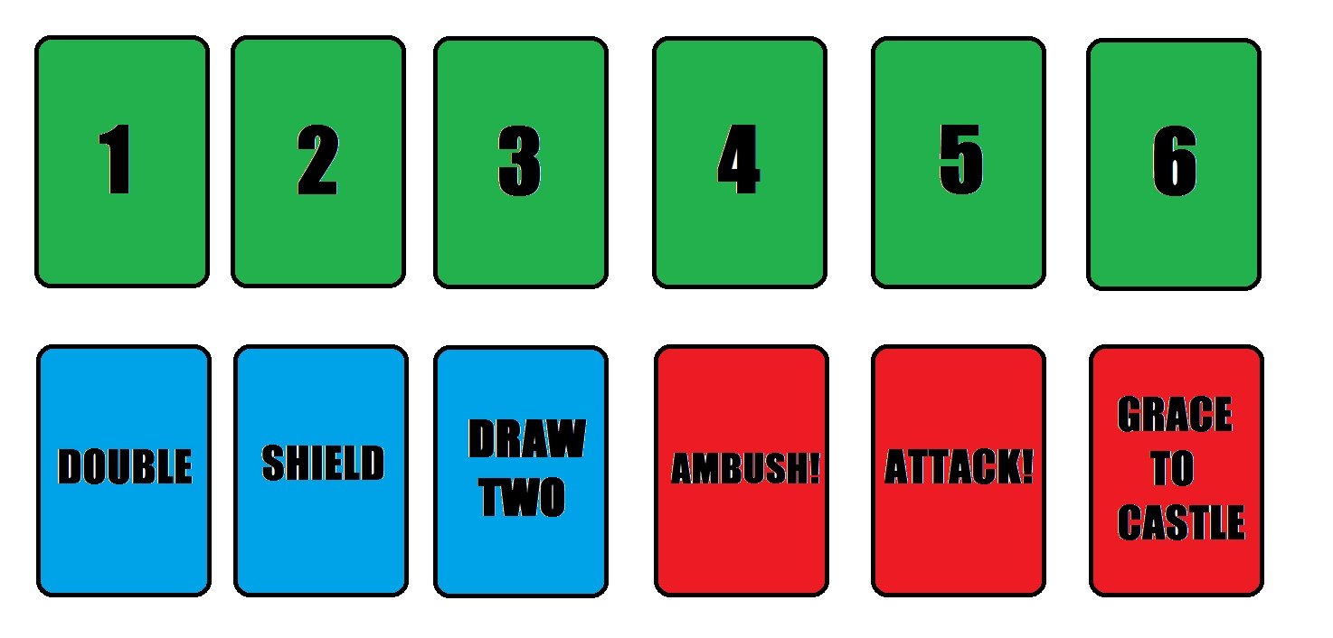
      1. **Green -** Basic number cards, indicate the number of spaces a player may move. The 6 card doubles as a grace card which allows another draw
      2. **Blue - Power-up Cards**

**Double -** Allows the player to double the value on the next drawn green card

**Shield -** Allows a player to apply a shield to one of their pieces that will protect them from being bumped or attacked for one round of play

**Draw two -** allows a player to draw an extra card

**5.1.3 Red - Action cards**

**Ambush -** Allows a player to move one piece from it’s starting position to an opposing player’s position, bumping that piece home in the process

**Attack -** Allows a player to, if they so choose, challenge an opposing player. This is only allowed if both players have a piece in the field of play (not allowed from the starting position). Both players draw cards until they both have drawn a green number card. The player with the higher number wins the challenge and a tie is resolved by redrawing. If the challenger wins, they may move their piece to that occupied by their opponent, bumping the piece in the process. If the challenging player loses, they forfeit their subsequent turn.

**5.2 Game Board**

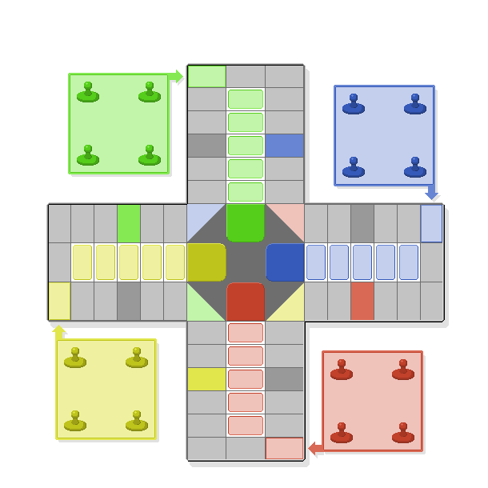

**5.2.1 Start**

This area is where the players’ four pieces are initially. The pieces remain in this area until a card is drawn allowing a player to move into the playing field. When entering the board by means of a Grace, the player’s piece moves from the Start are to the colored square indicated by an arrow.

**5.2.2 Playing Field**

The playing field is the area of the board represented by grey and colored rectangles. This area of the board is where players are allowed to move their pieces in attempt to reach the Home space.

**5.2.3 Home**

The Home space is the center square on the board. Once a player moves their piece to this space, that piece is no longer in play. A player has won once all 4 of their pieces have reached the Home space

1. **Appendix: Game Rules**
   1. **Overview**

The game is played with 2-4 players each having 4 game pieces. The object of the game is to become the first player to move all four pieces from their starting position to the home position first.

**6.2 Gameplay**

**6.2.1 Game Start**

To start the game, all 4 players draw cards until everyone has one of the green number cards. The player with the highest card starts the game. If two players receive the same card then only those two players will draw again.

**6.2.2 Normal Gameplay**

Gameplay proceeds counterclockwise around the board. Each player begins his turn by drawing a card from the pile and proceeding appropriately. If the player draws a green card they will have the option of moving one of their pieces accordingly and that will conclude their turn. If a player draws a red action card, they are able to play as stated by the card and that will conclude their turn. If a player draws a blue “power-up” card then they will continue to draw until either a red or green card appears and then play that card accordingly, applying any power-ups accumulated.

**6.3 Game End**

The game ends once a player has moved all of their pieces to the Home space on the board. A piece may only move home on an exact card draw.

**6.4 Other Rules**

Special squares on the board called “castles” represent safe zones for the player indicated by the space’s outlining color. When a player is in his own castle, he may not be bumped or attacked by another player.

**References**

“The Rules of Pachisi & Chaupur.“ *Masters Traditional Games.* Masters Games,

2012. Web. 30 January 2014.

<<http://www.mastersgames.com/rules/pachisi-rules.htm>>

Walker, Damian. “Traditional Board Game Series - Leaflet #20: Pachisi”. n.p. n.d. Brochure.